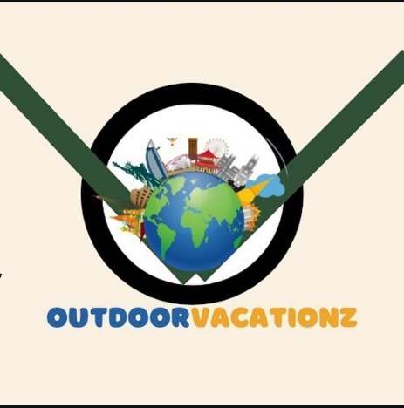
Destination- Malaysia ( Kuala Lumpur + Langkawi)

No. Of Person: 04 Adults

No. of nights – 6N 7Days

Hotel 4*

Package cost Per person INR 37,000-/ Including Service Tax.

Complimentary Insurance

Inclusions Malaysia (Kuala Lumpur + Langkawi):

- Daily Buffet breakfast at hotel

- 6Night stay at above mentioned hotel

- Half Day City Tour with KL Tower (Observation Deck) (Without guide) (4 Hours)

- Full Day Genting Highlands Tour with Photo Stop at Batu Caves with Cable Car Tickets

- Langkawi Mangrove River Safari and Eagle Feeding Tour with Lunch (Morning Slot) on sharing basis

- Langkawi Oriental Village Tour (Sky dome, Skyrex and 3D Art Gallery) with Cable Car, Sky Bridge and Sky Glide

- All Sightseeing on Private basis

- Airport pick-up and drop Private basis

Exclusion:

- Any compulsory room supplement during the tour.
- Video and Camera permits at sights.
- Meals outside of the stated meal plan.
- Use of vehicle other than the specified itinerary.
- Expenses of personal nature.
- Any other services not specified above.
- Late check-out and Early check-in

Suggested day wise Itinerary

Day01: Arrive at Langkawi airport meet our representative & proceed to the hotel check-in to the hotel, this is your leisure day explore the day by own, overnight at the hotel

Day 02: breakfast at the hotel then Langkawi Oriental Village Tour (Sky dome, Skyrex and 3D Art Gallery) with Cable Car, Sky Bridge and Sky Glide | PRIVATE
Embark on an exhilarating journey through Oriental Village! Explore the immersive wonders of the Sky dome, brave the thrilling Skyrex, and marvel at the captivating 3D Art Gallery. Then, soar to new heights on the Cable Car, traverse the breathtaking Sky Bridge, and glide through the skies on the Sky Glide
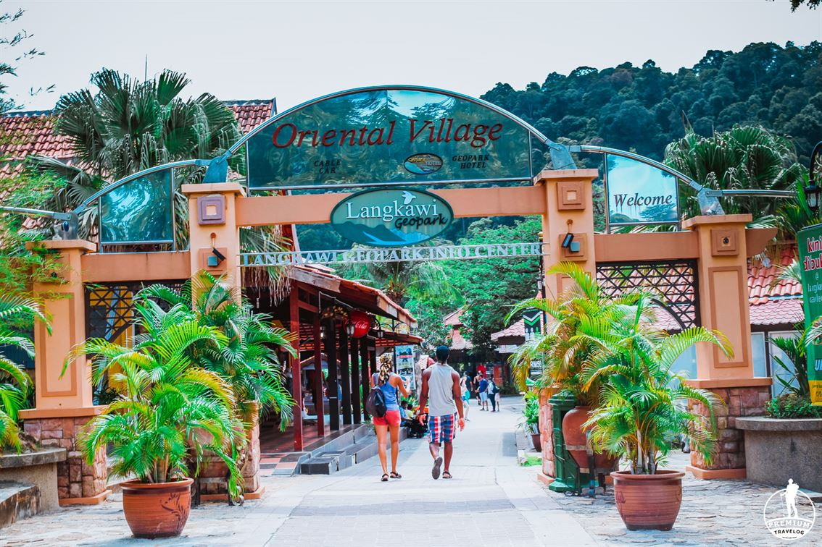

Day03: breakfast at the hotel Enjoy Sightseeing Langkawi Mangrove River Safari and Eagle Feeding Tour with Lunch (Morning Slot) with sic basis
Embark on a captivating river safari from Kilim Mangrove Reserve. Witness unique mangrove root formations and spot diverse wildlife, including Brahminy Kite eagles and White Belly Sea eagles. Explore a fish breeding farm, visit Bats Cave with its mesmerizing stalactite formations, and cruise through Crocodile Cave. Conclude with a glimpse into open sea fish farming, all while enjoying a delicious lunch.

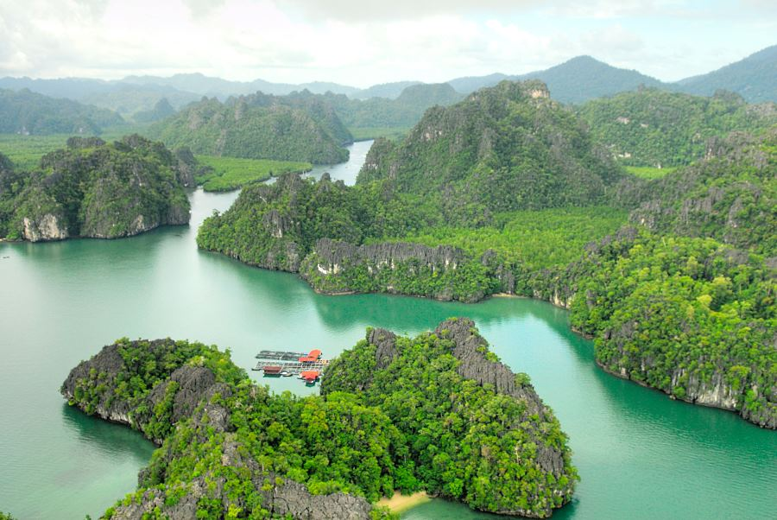

Day04: Have breakfast at the hotel take flight for Kuala Lumpur reach Kuala Lumpur meet our representative & proceed to the hotel check-in hotel , you are free for this day do some shopping and explore the city , overnight at the hotel.

Day05: Have breakfast then ready to Embark on an exciting City Tour in Kuala Lumpur, featuring the iconic KL Tower, one of the tallest towers in the world. Begin your journey with breathtaking panoramic views of the city skyline from the Observation Decks (TH01 & TH04), offering unique perspectives of Kuala Lumpur’s landmarks. Elevate your experience with a visit to the Sky Deck, an open-air viewing platform that takes your adventure to new heights with unobstructed views and a touch of thrill. Perfectly suited for self-guided explorers, this tour allows you to immerse yourself in the vibrant energy and architectural beauty of the city at your own pace.
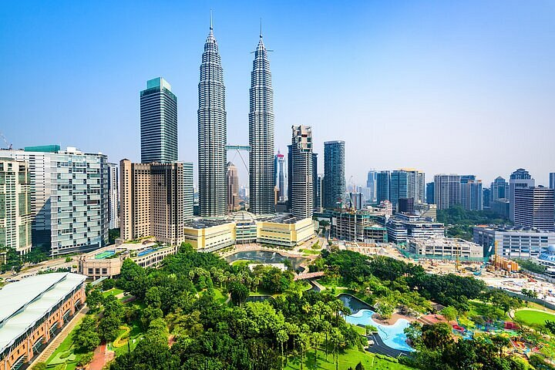

Day 06: Have breakfast at the hotel Full Day Genting Highlands Tour with Photo Stop at Batu Caves with Cable Car Tickets | PRIVATE

Embark on a high-altitude adventure to Malaysia’s sole casino resort, nestled 6,000 feet above sea level. Start with a scenic 20-minute stop at Batu Caves before venturing to Genting. Glide on the longest and fastest cable car in Southeast Asia to reach the hilltop, where the Chin Swee Caves Temple awaits amidst stunning surroundings.

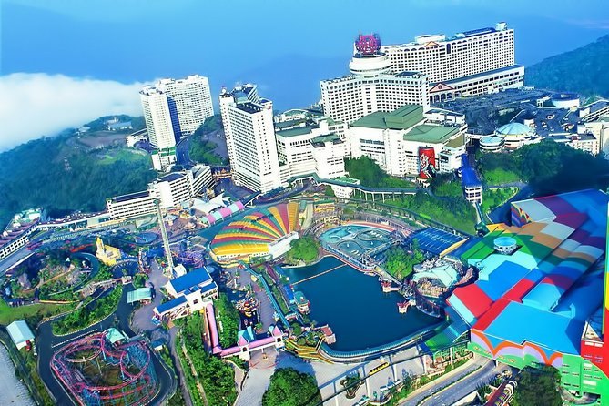

Day06: Have breakfast at hotel then ready for transfer to the airport according to your flight timing reach INDIA with sweet memories.

